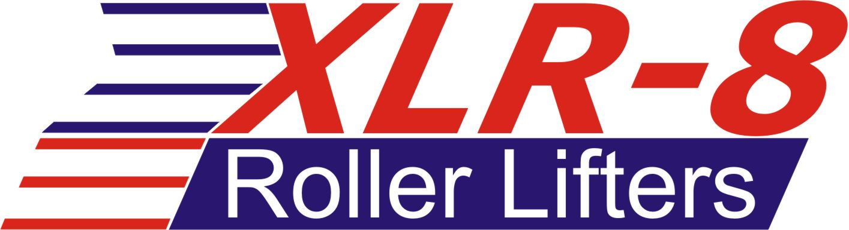
It’s not revolutionary. It’s Evolutionary !
Introducing “EVO-16”, the ultimate upgrade to your XLR-8R roller lifters. Our EVO-16 upgrade makes our XLR-8R lifters, the most indestructible lifters available. Our exclusive steel-on-steel roller design, replaces the need for needle bearings, or bronze bushings. The larger effective axle diameter allows for increase rigidity over other lifters. Rated for spring pressures over 1,600lbs, you won’t find a more durable lifter.
XLR-8 Series Lifters feature increased diameter oil band for maximum rigidity. Roller bearing pocket is designed for excellent shrouding of the roller bearing, providing strength and stability with smooth rounded edges that minimize lifter bore wear.
XLR-8R Series Lifters feature 4-column design for ultimate strength and rigidity while minimizing mass. Deep roller bearing pocket provides maximum roller bearing shrouding, maximizing rigidity and thrust surface area with smooth rounded edges that minimize lifter bore wear.

- Triple Alloy Steel Billet Lifter Bodies machined on state of the art CNC equipment.

- “One step machined” for ultimate relational accuracy of all part features.

- Heat treated for maximum strength, hardness and straightness in ISO certified furnaces.

- Precision Ground Bodies for proper fitment in aftermarket and stock lifter bores.

- Link Bars made of hardened, high strength, and high ductility Nickel-Chromium Alloy Steel.

- The fully hardened alloy steel button is secured with a non-removable, high strength, fatigue resistant rivet.

- Premium Alloy Steel Needle Roller Bearings feature crowned outer rings, micro-polished and micro-sorted roller needles, hardened and nitrided bearing steel axles.

- Proprietary “4-Port” Pressure fed oiling provides continuous oil to the axle and roller bearing.

- All lifter bodies will clear both stock and aftermarket .300" tall lifter bores.

- Custom modifications are available.

- All our XLR-8R lifters are rebuildable.

- BB-1350 Bushing Upgrade , available for all XLR-8R lifters, Rated for spring pressures up to 1,350lbs

- EVO-16 Steel on Steel Upgrade , available for all XLR-8R lifters, Rated for spring pressures up to 1,600lbs

JONES CAM DESIGNS • 7859 Commerce Dr, Denver NC 28037 • (704)489-2449 www.jonescams.com

